**Name of the College: NIIT R.G.P.G College Meerut **

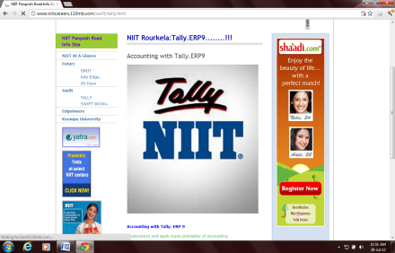 Student Name:________________________________Reg no:________________________

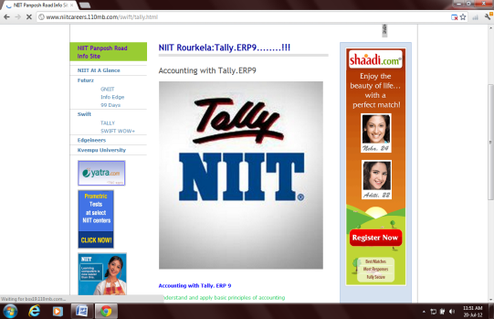 Class:______________Date:_________________Time:30 Min Max Marks: 100 Marks **B-Set-2**

**QUALIFYING EXAM OF TALLY**

|  |  |  |  |  |  |  |  |
| --- | --- | --- | --- | --- | --- | --- | --- |
| SN | QUESTION_STATEMENT | ANS_A | ANS_B | ANS_C | ANS_D | ANS_E | Ans |
| 1 | Allow aliases option is associated with | stock items | stock group | ledger name | ledger group | all of these | e |
| 2 | Part number option is associated with | stock items | stock group | ledger name | unit of measurement |  | a |
| 3 | Does Purchase and Sales order affect stock position ? | Yes | No |  |  |  | b |
| 4 | To keep bill details for a party choose | Maintain Billwise Breakups | Maintain Bill Details | Maintain Billwise Details | None of these |  | c |
| 5 | Shortcut key for Cancellation of Voucher | Alt + 2 | Alt + X | Ctrl + 2 | None of these |  | b |
| 6 | Cost centre report is available in | statements of accounts | statements of inventory | Accounts Book | Exception Report |  | a |
| 7 | UDF is possible in Tally | a) True | b) False |  |  |  | b |
| 8 | Is it possible to see profit or loss both as liability | a) True | b) False |  |  |  | a |
| 9 | To shut a Company | Click on taskbar | Click On gateway of Tally | Click on Shift +N Button | Click On Alt+f1 button | None of the above | d |
| 10 | Can we define Credit limit for debtors & creditors ? | yes | no |  |  |  | a |
| 11 | To prepare Manufacturing Voucher you have to depend on | Stock Journal | Sales | Purchase | Any one of them | None of these | a |
| 12 | Discrepancy between Actual stock and Computer stock is termed as | Actual Level | Stock Verification | Reorder Level | Voucher Class | Physical Stock | e |
| 13 | What is the hot key to open an Accounting Voucher ? | Press - V | Press - A | Press - D | None |  | a |
| 14 | Suspense A / c in Tally falls under | Assets | Liabilities | Incomes | Expenses |  | b |
| 15 | How we can pass entry without any value | a) F11 > allow 0 valued entries in vouchers | c) Is not possible |  |  |  | a |
| 16 | Invoice format for Sales / Purchases can be turned ON from | Company Configuration | Company Info menu | Company Features window | Company Alteration window | None of these | c |
| 17 | The shortcut key used for Optional Vouchers | Ctrl + T | Ctrl + A | Ctrl + O | Ctrl + L |  | d |
| 18 | Budget report can be seen from | Display -Trial Balance | Display - Accounts Book - Cash Bank Book(s) | Display - Statement Of Accounts | Both A & B | None of these | d |
| 19 | To convert a Sales entry from Voucher mode to Invoice mode use | F9 | F8 | Alt + V | Ctrl + V | None of these | d |
| 20 | Invoices are classified in | 2 categories | 5 categories | 8 categories | 6 categories | None of the above | a |
| 21 | We can maintain more than one user & passward in tally | True | False |  |  |  | a |
| 22 | No entries in voucher this message comes when there is | no debit side in the entry | no credit side in the entry | no amount in the entry | no date in the entry |  | c |
| 23 | F11 in Tally refers to | Company details | Company configuration | Company features | Company ACCOUNTS | All of the above | c |
| 24 | Purchase order in tally Comes by | Alt + P | Ctrl+P | Alt+R | Alt+O | None of these | e |
| 25 | In case of Date Setting is there any difference between F2 & Alt + F2 key ? | Yes | No |  |  |  | a |
| 26 | Sale Bill and Purchase Bill can be entered only in | Voucher mode | Invoice mode | Both A & B | None of these |  | c |
| 27 | The shortcut used to find Group Company | Alt + F1 | Alt + F2 | Alt + F3 | Alt + F4 |  | c |
| 28 | Is it possible to define item wise price list ? | yes | no |  |  |  | a |
| 29 | Bill of materials option is related with | scenario | manufacturing | reversing journal | budget |  | b |
| 30 | To create Duplicate voucher press | Alt + F2 | Ctrl + F2 | Alt + 2 | Ctrl + 2 |  | c |
| 31 | By default Profit & Loss A / c is created under which Group ? | Capital | Reserve & Surplus | Primary | Profit & Loss. |  | c |
| 32 | Is it possible to see vertical balance sheet | a) True | b) False |  |  |  | a |
| 33 | Display of Sundry debtors without ledger breakup cannot be possible in Tally | True | FALSE |  |  |  | b |
| 34 | Single mode of Voucher entry is possible in Tally | True | False |  |  |  | a |
| 35 | To display Outstanding report for Debtors select | Gateway of Tally > Display > Exception Reports > Debtors | Gateway of Tally > Display > Statements of Accounts > Outstanding > Receivables | Gateway of Tally > Display > Statements of Accounts > Outstanding > Debtors | None of these |  | b |
| 36 | Goods received on account of purchase is related with | Delivery Note | Receipt Note | Purchase Note | Sales Note | None of these | b |
| 37 | There is no difference between Cancellation and Deletion of Voucher ? | True | False |  |  |  | b |
| 38 | The shortcut to open Payment Voucher Mode . | Press F5 | Press F6 | Press F8 | Press F9 |  | a |
| 39 | Costing method of an item in Tally can be maintained in | 2 Ways | 9 ways | 4 ways | 8 ways | Costing cannot be done | b |
| 40 | "To display the ""inventory values are affected"" at the time of ledger creation "" press F12"" to active " | a) Use ADDRESS for ledger accounts | b) Allow ADVANCED entries in master from Inventory master | c) Allow ADVANCED entries in master from Accounts Master | d) None of these |  | c |
| 41 | The option - Rejection out - is used during | Payment | Sales | Purchase | Receipt |  | c |
| 42 | To transfer the amount from Main Cash to Petty Cash you have to use | Payment mode | Receipt mode | Contra mode | None of these |  | c |
| 43 | If we select - Accounts Only - feature can we maintain stock item ? | Yes | No |  |  |  | b |
| 44 | Is it possible to maintain Income and Expenditure Stmt instead of P / L A / c ? | True | False |  |  |  | a |
| 45 | Choose the correct shortcut key to export. | Alt + X | Alt + E | Alt + P | Alt + T |  | b |
| 46 | CST in purchase is deducted from | Sale amount | Purchase amount | None of the above | All of the above |  | c |
| 47 | Simple & Compound Interest are same in Tally | True | False |  |  |  | b |
| 48 | To Shut an opened Company the shortcut is | Alt + F1 | Shift + F1 | Ctrl + F1 | None of these |  | a |
| 49 | Discount Allowed ledger is created under _________ group | Direct Income | Indirect Income | Indirect Expenses | Direct Expenses |  | c |
| 50 | Input Vat ledger falls under | Indirect Expenses | Duties and Taxes | Sales | Purchases | Indirect Incomes | b |